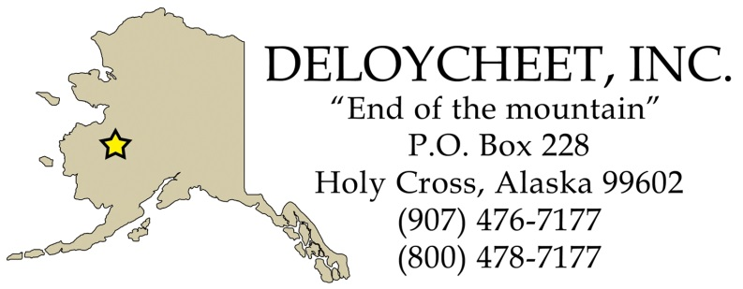

Deloycheet Incorporated
2018 Annual Shareholder Meeting
October 5, 2018 Door Prize Winners

Early Bird Winners: Stock Will Winner:
- $500.00 – Alphonse Edwards $500.00 – Carol Atkins
- $400.00 – Edith Morgan
- $300.00 – Terrance Peters
- $200.00 – Miranda Marcel
- $100.00 – Michael Nerby

Door Prize Winners:
- $500.00 – Clinton Demientieff
- $400.00 – Alexander Edwards
- $300.00 – Reginald Kalkins
- $200.00 – Terrance Peters
- $100.00 – Benedict Peters
- $50.00 Visa Gift Card – Donald Peters
- $50.00 Visa Gift Card – Ray Turner
- $50.00 Visa Gift Card – Gregory Savage
- $50.00 Visa Gift Card – Kristen Lepore
- Beaded Sun catcher Made by Carolyn Campbell-Burkett of Holy Cross – Samuel Demientieff
- Beaded Ball Sun catcher made by Carolyn Campbell-Burkett of Holy Cross of Holy Cross – Laura Sims
- Beaded Credit Card holder Make by Carolyn Campbell-Burkett of Holy Cross – Evan Newman

